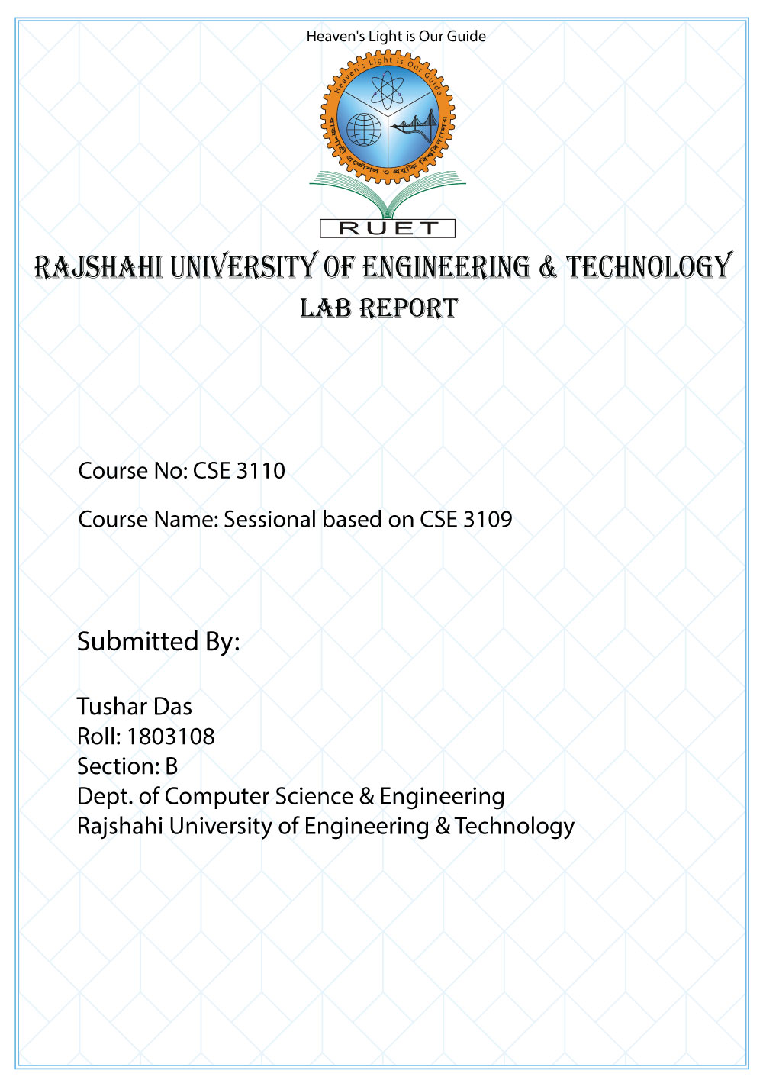

**Problem: Reverse a string word by word and set the vowels lowercase**

**Algorithm**

* Input a string into a variable
* Traverse the string characters and push it in the stack until it finds a space
* If a space is found then pop the characters from the stack
* Repeat step 2 and 3 until the string ends

**Code**

;reverse a string word by word

;show the consonant uppercase and vowels lower case

.MODEL SMALL

.STACK 100H

.DATA

MSG1 DW ?

.CODE

MAIN PROC

MOV AX,@DATA

MOV DS,AX

MOV CX,0

MOV SI,0

MOV DI,0

MOV AH,1

L1:

INT 21H

CMP AL,0DH

JE L1_END

CMP AL,'A'

JE CHECK_VOWEL

CMP AL,'E'

JE CHECK_VOWEL

CMP AL,'I'

JE CHECK_VOWEL

CMP AL,'O'

JE CHECK_VOWEL

CMP AL,'U'

JE CHECK_VOWEL

MOV MSG1[SI],AX

INC SI

JMP L1

CHECK_VOWEL:

ADD AL,32

MOV MSG1[SI],AX

INC SI

JMP L1

L1_END:

MOV AH,2

MOV DL,0DH

INT 21H

MOV DL,0AH

INT 21H

L2:

MOV BX,MSG1[DI]

CMP BL,' '

JE POP_START

PUSH MSG1[DI]

INC DI

INC CX

CMP DI,SI

JE POP_START

JMP L2

POP_START:

MOV AH,2

POP DX

INT 21H

LOOP POP_START

MOV AH,2

MOV DL,032

INT 21H

INC DI

CMP DI,SI

JG END_

JMP L2

END_:

END MAIN

OUTPUT

